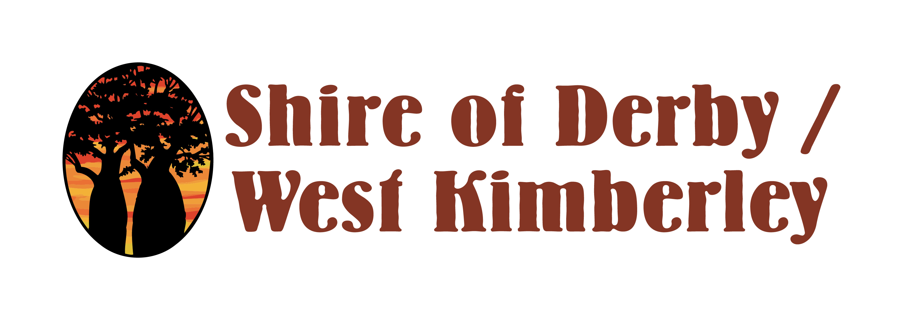

DISABILITY ACCESS AND INCLUSION PLAN
COMMUNITY SURVEY 2021

INTRODUCTION

This survey is part of a review of the Shire of Derby and West Kimberley Disability Access and Inclusion Plan (DAIP) 2016-2021. The purpose of the survey is to assess how effective the Shire has been in ensuring that all people, including people with disability, have access to buildings, information, public consultations, complaints processes, services and employment. Results from the survey will be used to develop a new DAIP for 2022-2026.

This survey is being conducted by E-QUAL Disability Consultants. All survey responses will remain confidential.

If you would prefer this survey in an alternative format or a telephone interview please contact Leanda Syme from E-QUAL on 9389 9930 or leanda@e-qual.net

Please return your completed survey to one of the Shire offices or post it to PO Box 200 Nedlands WA 6009 by 29th November 2021.

ACCESS AND INCLUSION AT THE SHIRE OF DERBY AND WEST KIMBERLEY

- Please rate your level of agreement with the following statement:

Overall I am satisfied that the Shire of Derby and West Kimberley provides an environment which is inclusive of people with disability.
- Strongly disagree
- Disagree
- Neither
- Agree
- Strongly agree
- Don’t know/Not applicable

Are you aware of any difficulties experienced by people with disability regarding:

- Accessing programs, services and events? For example Library Services, Youth Activities, School Holiday Programs, Festivals or Events, Waste Services, Ranger Services and Planning/Building Services.
  - No
  - Yes (please provide details)
  - Don't know/Not applicable

- Access to buildings, facilities, outdoor environments and other public spaces? For example Administration Centre, Libraries, Aquatic Centre, Parks and Reserves and Community Halls.
  - No
  - Yes (please provide details)
  - Don't know/Not applicable

With respect to accessing information at the Shire of Derby and West Kimberley, are you aware of any difficulties experienced by people with disability regarding:

- Access to written/printed information? For example books, pamphlets, reports, signage.
  - No
  - Yes (please provide details)
  - Don't know/Not applicable

- Access to on-line information? For example Shire website, Facebook, Twitter.
  - No
  - Yes (please provide details)
  - Don't know/Not applicable

- Obtaining information in alternative formats? For example electronic, hard copy, large print, audio format.
  - No
  - Yes (please provide details)
  - Don't know/Not applicable

- Please rate your level of agreement with the following statement:

Shire of Derby and West Kimberley staff have a reasonable level of awareness and skills regarding people with disability.
- Strongly disagree
- Disagree
- Neither
- Agree
- Strongly agree
- Don’t know/Not applicable

- If you ‘strongly disagree’ or ‘disagree’ why do you give this rating?

- Does the Shire of Derby and West Kimberley provide adequate opportunities for people with disability to provide feedback or make complaints?
  - No
  - Yes
  - Don't know/Not applicable

- If no, why not? Please select all that apply.
  - Inaccessible feedback or complaints procedure
  - Alternative format material not provided in a timely fashion
  - Lack of information on how to provide feedback or make a complaint
  - Lack of staff knowledge and skills to advise/support a person wanting to provide feedback or make a complaint
  - Lack of feedback about outcomes of complaints
  - Other (please provide details)

- Does the Shire of Derby and West Kimberley provide adequate opportunities for people with disability to take part in consultations? For example forums, workshops, surveys.
  - No
  - Yes
  - Don't know/Not applicable

- If no, why not? Please select all that apply.
  - Information promoting the consultation not in accessible formats
  - Consultation venue not accessible
  - Processes to provide comment not accessible
  - Lack of skilled staff to support participation
  - Consultation documents not in plain English
  - Consultation documents provided in accessible format too late for comment
  - Lack of feedback about outcomes of consultation
  - Other (please provide details)

- Do you think the Shire of Derby and West Kimberley provides adequate opportunities for people with disability to obtain employment?
  - No
  - Yes
  - Don't know/Not applicable

- If no, why not? Please select all that apply.
  - Vacancies not promoted in ways that are accessible
  - Recruitment practices not accessible e.g. interview venue not accessible, assessment methods not accessible, information not provided in preferred format
  - Staff not aware of support available for employees with disability e.g. funding for adaptive equipment, disability employment services
  - Staff don’t understand the benefits of employing a person with disability
  - Other (please provide details)

- What do you think the Shire of Derby and West Kimberley could do to improve access and support a more inclusive community?

INFORMATION SOURCES

- How would you like the Shire of Derby and West Kimberley to keep you up to date with information about support and services available to people with disability? Please select all that apply.
  - E-Newsletters
  - Local newspaper
  - Shire social media
  - Shire website
  - Do not wish to receive such information
  - Other (please provide details)

- Please provide your details below if you are interested in being part of further discussions about access and inclusion at the Shire of Derby and West Kimberley. The details you provide will only be used to contact you and will not be shared.

First Name:

Last Name:

Email:

Phone:

ABOUT YOU

- Which locality do you live in?
  - Derby
  - Fitzroy Crossing
  - Camballin
  - Station or pastoral location
  - Aboriginal community
  - A locality outside the Shire of Derby and West Kimberley

- Are you (select all boxes that apply):
  - A person with disability
  - A family member or carer of a person with disability
  - A person who works in the disability sector
  - Other (please describe) ________________________

- If you would like to go in the draw to win a $50 gift voucher, please fill in the details below. Your details will only be used to contact you if you are a winner and will not be shared.

First Name:

Last Name:

Email:

Phone:

Thank you for completing this survey. Your feedback is very much appreciated.

