

Expression of Interest

|  |  |
| --- | --- |
| **Expression of**  **Interest (EOI):** | Derby Airport Hangar Lease  Old RFDS Building |
|  | |
| **Deadline:** | 4:00pm, Thursday 31 July 2025 |
|  | |
| **Address for**  **Delivery:** | Shire Derby West Kimberley  30 Loch Street, Derby. 6728  sdwk@sdwk.wa.gov.au |

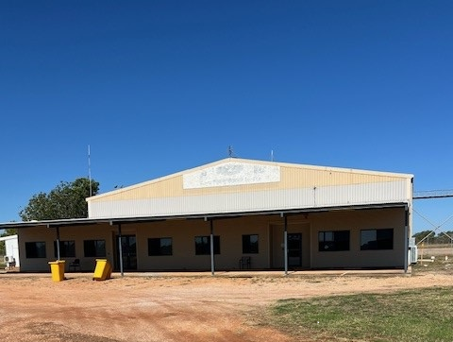

**Contents**

**1 Conditions of Responding .......................................................................................... 1**

1.1 Definitions............................................................................................................... 1

1.2 Expression of Interest Documents .......................................................................... 2

1.3 How to Prepare Your Submission ........................................................................... 2

1.4 Contact Persons ..................................................................................................... 2

1.5 Lodgment of Submissions and Delivery Method ..................................................... 2

1.6 Rejection of Submissions........................................................................................ 2

1.7 Acceptance of Submissions .................................................................................... 3

1.8 Respondents to Inform Themselves........................................................................ 3

1.9 Ownership of Submissions...................................................................................... 3

1.10 Canvassing of Officials ........................................................................................... 3

**2 Specification ................................................................................................................ 4**

2.1 Introduction ............................................................................................................. 4

2.2 Background Information .......................................................................................... 4

2.3 Specific Requirements ............................................................................................ 4

**3 Respondent’s Submission .......................................................................................... 7**

3.1 Response Form ...................................................................................................... 7

**1 Conditions of Responding**

**1.1 Definitions**

Below is a summary of some of the important defined terms used in this Expression of Interest:

|  |  |
| --- | --- |
| **Attachments:** | The documents you attach as part of your Submission. |
| **Deadline:** | The Deadline shown on the front cover of this Expression of Interest for lodgment of your Submission. |
| **Expression of**  **Interest or EOI:** | This document. |
| **Principal:** | Shire Derby West Kimberley |
| **Respondent:** | The person or persons, corporation or corporations who intends to submit a Submission in response to an Expression of Interest. |
| **Requirement:** | The Services requested by the Principal. |
| **Specification:** | The Statement of Requirements for Services that the Principal’s Expression of Interest may request you to provide if selected as an acceptable Expression of Interest through the Expression of Interest process. |
| **Submission:** | Completed Expression of Interest, response to specific requirements and attachments. |

**1.2 Expression of Interest Documents**

This Expression of Interest is comprised of the following parts:

Part 1 – Conditions of Responding *(read and keep this part)*. Part 2 – Specification *(read and keep this part).*

Part 3 – Respondent’s Submission *(read and keep this part)*.

**Separate Documents**

a) Addenda and any other special correspondence issued to Respondent’s by the Principal.

b) Any other policy or document referred to but not attached to the Expression of

Interest.

**1.3 How to Prepare Your Submission**

a) Carefully read all parts of this document;

b) Ensure you understand the Requirements (Part 2);

c) Complete the Response Form (Part 3) and your response to the Specific Requirements

(Part 2) and attach your Attachments;

d) Make sure you have signed the Response Form and responded to all the Selection

Criteria; and

e) Lodge your Submission before the Deadline.

**1.4 Contact Persons**

Respondents should not rely on any information provided by any person other than the person listed below:

|  |  |
| --- | --- |
| **Name:** | Tamara Clarkson. CEO |
| **Telephone:** | 08 9191 0999 |
| **Email:** | [sdwk@sdwk.wa.gov.au](mailto:sdwk@sdwk.wa.gov.au) |

**1.5 Lodgment of Submissions and Delivery Method**

The Submission must be lodged by email Addressed to the CEO by the Deadline. The deadline for this Expression of Interest is **4:00pm, Thursday 31 July 2025**

**1.6 Rejection of Submissions**

A Submission will be rejected without consideration of its merits in the event that:

a) it is not submitted before the Deadline; or

b) it is not submitted at the place specified in the Expression of Interest; or

c) it may be rejected if it fails to comply with any other requirements of the Expression of Interest.

**1.7 Acceptance of Submissions**

Unless otherwise stated in this Expression of Interest, Submission may be for all or part of the Requirements and may be accepted by the Principal either wholly or in part. The Principal is not bound to accept and may reject any or all Submissions submitted. The acceptance of a Submission does not oblige the Principal to proceed to issuing any planning or building approvals.

**1.8 Respondents to Inform Themselves**

Respondents shall be deemed to have:

a) examined the Expression of Interest and any other information available in writing to

Respondents for the purpose of submitting an EOI;

b) examined all further information relevant to the risks, contingencies and other circumstances having an effect on their Submission which is obtainable by the making of reasonable enquiries;

c) satisfied themselves as to the correctness and sufficiency of their Submissions;

d) acknowledged that the Principal may enter into negotiations with a chosen Respondent and that negotiations are to be carried out in good faith; and

e) satisfied themselves they have a full set of the EOI documents and all relevant attachments.

**1.9 Ownership of Submissions**

The Shire is conscious of the need to protect the intellectual property of respondents. All documents, materials, articles and information submitted by the Respondent as part of or in support of a Submission shall become upon submission the absolute property of the Principal and will not be returned to the Respondent at the conclusion of the Submission, however, will be treated as ‘Commercial in Confidence’ and that the Respondent shall be entitled to retain copyright and other intellectual property rights therein.

**1.10 Canvassing of Officials**

If a Respondent, whether personally or by agent, canvasses any of the Principal’s Councillors or Officers with a view to influencing the acceptance of any Respondent, then regardless of such canvassing having any influence on the acceptance of such Submission, the Principal may at its discretion omit the Respondent from consideration.

**2 Specification**

**2.1 Introduction**

Derby airport is owned and operated by the Shire Derby West Kimberley and is currently a Category 1 airport.

The principle is seeking proposals for the lease of the old RFDS building, located at the Derby airport, approx. 10kms East on the Derby Hwy from the Derby town centre,

**2.2 Background Information**

Hangar forms part of the infrastructure at the Derby Airport which is located approximately 10 kilometers East of the Derby town centre with the subject hangar being the first of the hangars on entry to the airport.

The hangar consists of a relatively new office extension, including ablutions, offices and meeting rooms and storage.

The Hangar will be leased on an as is basis and as such, some office furniture will be included in the Lease.

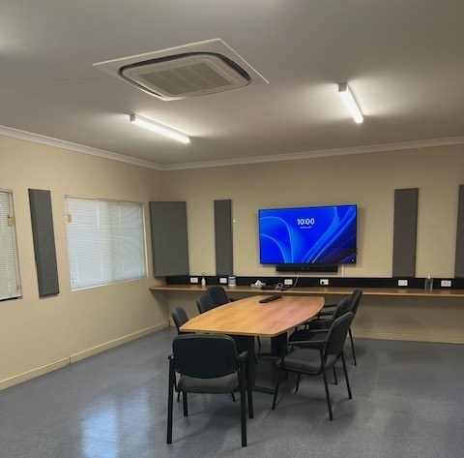

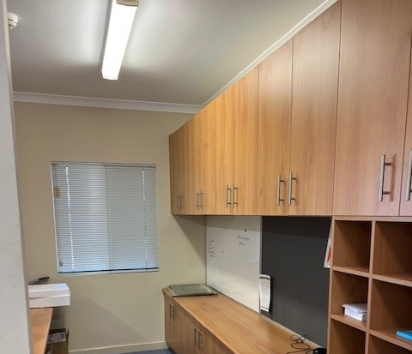

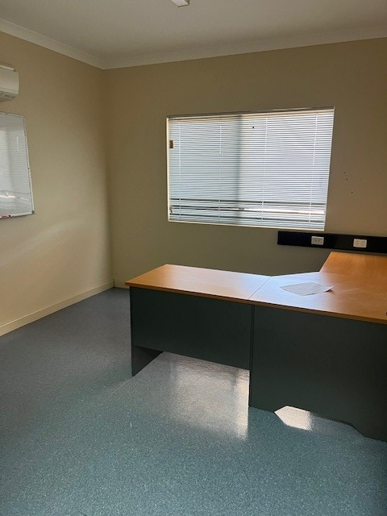

**2.3 Specific Requirements**

The Tenant should be aware of and conform with the following conditions of use:

Fit out of all internal offices and storerooms have been carried out, any further fit out must be carried out with the approval of the Shire Derby West Kimberley

The proposed lease conditions are as follows:

- Lease term is for 5 years with a further term option of 5 years;

- Lease fee is $26,700.00 plus GST PA paid in advance Quarterly.

- Lessee responsible for separately paying;

1. All applicable operational costs and other utilities

2. All other costs associated with the lease

All submissions are required to be accompanied by a business case that clearly address the following:

1. **The intended use and occupancy of the Hangar.**
2. **The capacity of the business to adequately cover the lease payments and all out goings.**

The designated lease area has approximately 650m2 of hangar space with approx. 380m2 of office space

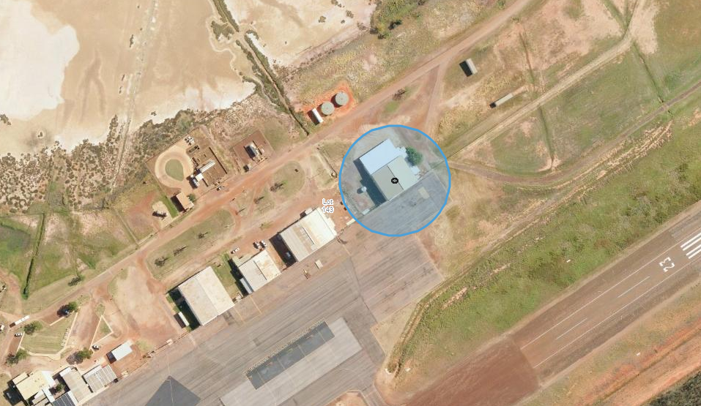

**3 Respondent’s Submission**

**3.1 Response Form**

The Chief Executive Officer

Shire Derby West Kimberley

I/We (Registered Entity Name): (BLOCK LETTERS)

of: (REGISTERED STREET ADDRESS)

ABN ACN (if any)

Telephone No: Facsimile No:

E-mail:

**In response to Expression of Interest – Derby RFDS Airport Hangar Lease**

I/We agree that I am/We are bound by, and will comply with this Expression of Interest and its associated schedules, attachments, all in accordance with the Conditions contained in this EOI signed and completed.

I/We agree that there will be no cost payable by the Principal towards the preparation or submission of this Submission irrespective of its outcome.

Dated this day of 20

Signature of authorised signatory of Respondent:

Name of authorised signatory (BLOCK LETTERS):

Position:

Telephone Number:

Authorised signatory Postal address:

Email Address: