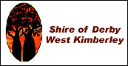

Shire of Derby/West Kimberley

RESULTS OF ELECTION (Form 19)

These are the results of the local government election for the positions of President and Deputy President, held on 18 October 2021:

Position | Name
President | Geoffrey Charles HAEREWA
Deputy President | Peter MCCUMSTIE

Neil Philip HARTLEY (Returning officer)
22 October 2021

